**Session Plan for Children.**

The session aims to work with children from S3 to S5 who are of the age group 13-16.

The children will be tested on the portions taught to them in S2 (already familiar, hence won’t require teaching.)

The S2 portion that the children will be tested on is ratio, proportion, percentages, algebra geometry, and numbers, which will be used as tags to keep track of the understanding of the child in each topic.

**TEMPLATE:**

**TAGS USED:** Ratio & Proportion, Algebra, Numbers, Fractions, Percentages, Geometry.

Q1)

**TAGS: Geometry**

Q2) **Paint Pro** makes pink paint by mixing red paint and white paint in the ratio 3:4. Colour Co makes pink paint by mixing red paint and white paint in the ratio 5:7. Which company uses a higher proportion of red paint in their mixture?

**TAGS: Ratio & Proportion**

Q3) Create a graph from a table.

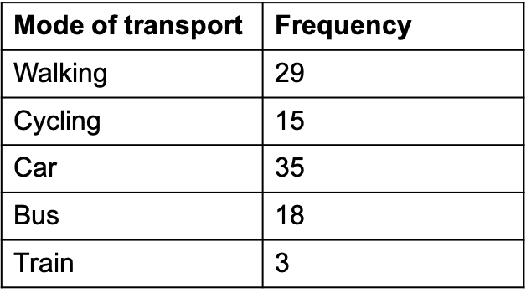 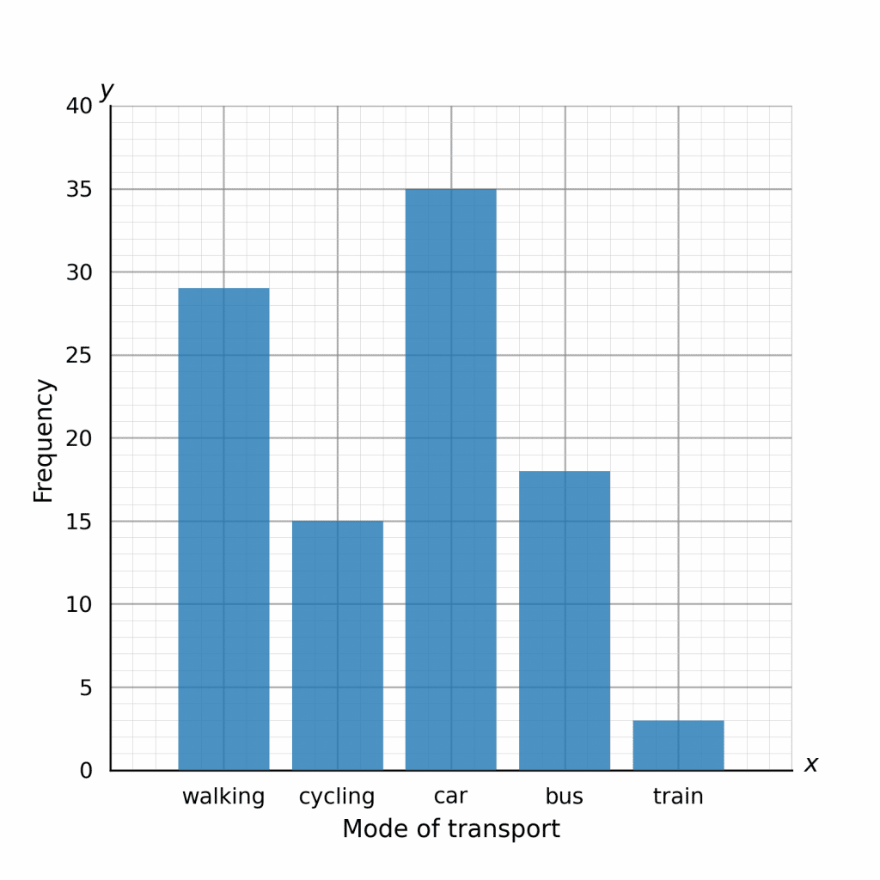

**TAGS: Algebra**

Q4) In this pyramid, you add two adjacent blocks to find the value of the block above. 12*a*−*b*

**TAGS: Algebra**

Q5)

**TAGS: Fractions**

Q6) Gary and Henry brought an equal amount of money for shopping. Gary spent $95 and Henry spent $350. After that Henry had 4/7 of what Gary had left. How much money did Gary have left after shopping?

**TAGS: Algebra, Fractions**

Q7) Rosa has brought a top worth £14 for sale. The sale was 30% off on all items. Calculate the original price of the top before it reduced.

**TAGS: Numbers, Algebra, Percentages.**

Q8)

**TAGS: Numbers, Geometry, Fractions**

Q9) Rahim is saving for a new bike which will cost £480. Rahim earns £1500 per month. Rahim spends his money on bills, food and extras in the ratio 8:3:4. Of the money he spends on extras, he spends 80% and puts 20% into his savings account. How long will it take Rahim to save for his new bike?

**TAGS: Numbers, Ratio & Proportions, Percentages**

Q10) Tim has a bag full of chocolates. He ate 4 chocolates, then he gave a third of what he had left to George. George ate 4 of his chocolates, then gave a third of what he had left to Aimee. Aimee got 3 chocolates in the end.

How many chocolates did Tim have in his bag at the start?

**TAGS: Numbers, Algebra, Fractions.**

Each of these questions will be framed on the H5P website using the interactive content type.